Operating Instructions

1x4 HDMI Splitter Over Single Cat5e/6 Cable
Up to 50M with IR
Model: H4SPC5L
Operating Instructions

Notice
The information in this document is subject to change without notice. Every effort has been made in the preparation of this document to ensure accuracy of the contents, but all statements, information, and recommendations in this document do not constitute the warranty of any kind, express or implied.

Features
- Distribute 1 HDMI signal to 4 identical UTP outputs synchronously,
with 1xlooping HDMI output.
- Transmit over 50m single Cat5e/6 cable.
- Can be cascaded for 4 layers.
- With wide-band Bi-Direction IR control (38 ~ 56 kHz).
(IR extension from Sender to Receiver or from Receiver to Sender)
- Support Full HD 1080p, VESA resolution: 1920x1200.
- Supports Dolby TrueHD, DTS-HD Master Audio.
- Support 3D.

Package Contents
- 1 x HDMI Splitter
- 1 x 12V DC Adapter
- 1 x User Manual
1
Operating Instructions

SPECIFICATIONS
Operating Temperature Range | -10℃-40℃(+14-140℉)
Operating Humidity Range | 5 to 90%RH (No Condensation)
Video Amplifier Bandwidth | 140MHz
Input Video Signal | 0.5-1.0 Volts P-P
Input DDC Signal | 5 volts p-p(TTL)
Data transfer speed rate | 6.75Gbps(Maximum)
Input port | 1xHDMI
Output ports | 4xCat5e/6, 1xHDMI
Video Format Supported | DTV/HDTV: 720P/1080i/1080P  VESA resolution:1920x1200①  3D video support
Vertical Frequency range | 60Hz
Support Audio Format | DTS-HD Master Audio, Dolby True HD, multi-channel 5.1, stereo etc ②
Transmission Distance | 1080P 8-bit 50m  Over single cat5e or cat6 cable/24AWG/Solid③
Power consumption | 12W(Max)
Dimension (L×W×H) | L203xW134xH29.2mm
Net Weight | 823.1g
Note: ① The transmission distance is Max 40m under 1920x1200 resolution.
② The distance is 40m under 5.1CH or 7.1CH.
③ Under perfect transmission conditions including straight cable runs with no electrical interference, bends, kinks, patch panels or wall outlets.

PANEL DESCRIPTIONS
Front Panel








1. Power on/off: press the up/down to open/close the device.
2. Power input indicator 3. Indicator of HDMI input
4. Indicator of HDMI output 5. DIP switch for EDID setting
6. IR-RX port 7. IR-TX port

2

Operating Instructions

Rear Panel






8. CAT-5E/6 out ports 9. HDMI output
10. HDMI input 11. Power input

DIP Switch for EDID Setting
DIP Switch | EDID
0000 | Default (1080P2D 2ch)
0001 | Copy from HDMI output
0010 | 1080P2D 2CH
0011 | 1080P2D 6CH
0100 | 1080P2D 8CH
0101 | Reserved
0110 | 1080P3D 2CH
0111 | 1080P3D 6CH
1111 | 1080P3D 8CH

Connecting and operating
1) Connect the HDMI input source into HDMI splitter.
2) Connect HDMI splitter and receiver by single cat5e/6 cable (The cable termination must follow the standard of EIA/TIA 568B).
3) Connect the HDMI display (such as HD-LCD/HD-DLP) into the HDMI output of
receiver.
4) Connect the Loop HDMI output port of HDMI Splitter with the HDMI Display (such as HD-LCD/HD-DLP) by HDMI cable.
5) Plug IR TX cable and IR RX cable to IR port of the Splitter.
6) Plug IR TX cable and IR RX cable to IR port of the Receiver.
7) Insert the DC 12V power supply into HDMI splitter and receiver.

3
Operating Instructions

Connection Diagram
Application 1:

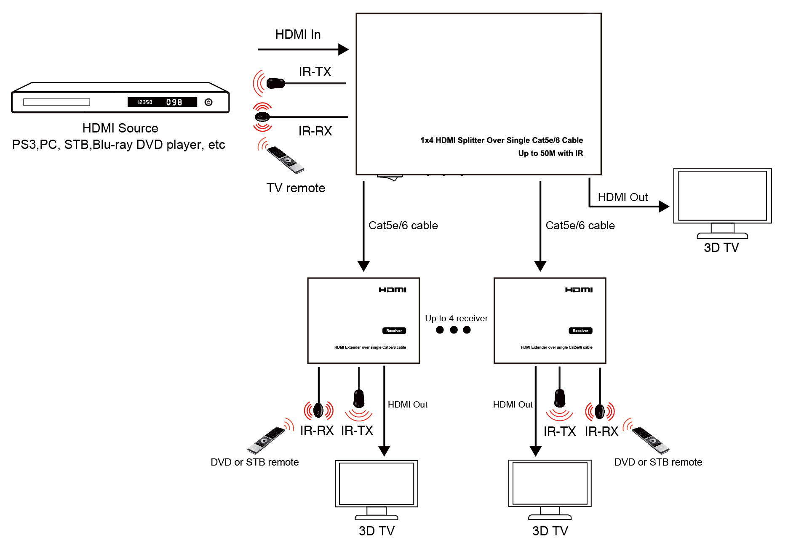

Application 2: Cascade for 4 layers

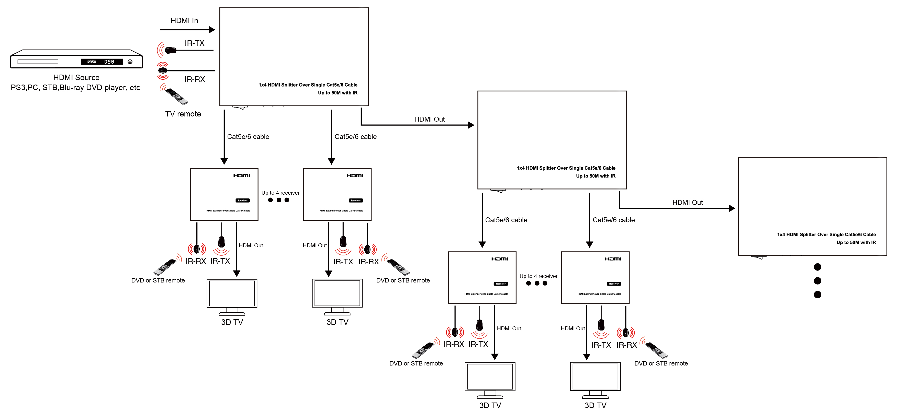

4
Operating Instructions



